# JS Advanced Exam Retake

## Problem 1. BookUni

### Use the provided skeleton to solve this problem.

### You can't change directly the given html code.

### Your Task

**Write the** **missing JavaScript code** to make the **Book Store (BookUni)** work as expected:

* When **all fields (title, year and price)** are **filled with correct input**
  + **Title** is **non**-**empty** **strings**
  + **Year** and **Price** need to be **positive** **numbers**

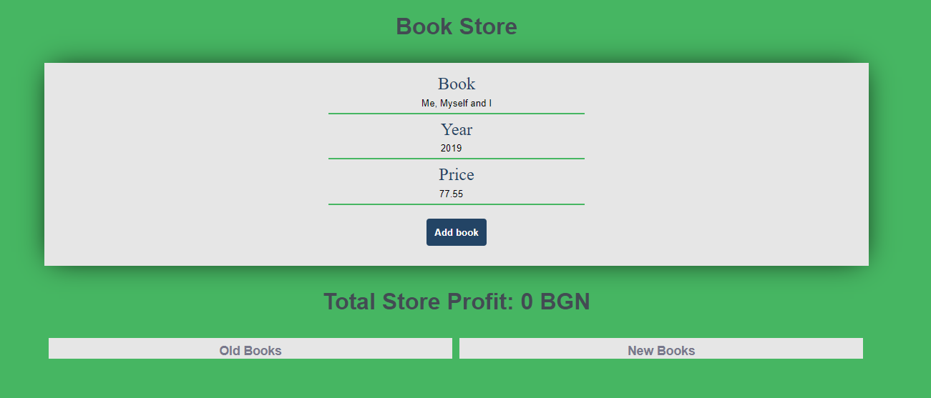

* Upon pressing the **[Add new book]** **button**, a new book should appear in the bookshelf section (**look down the constraints**). Create new **div** **element** with **class** **book** (for every created book) which hold:
  + **paragraph** with text content of the given book title and the given book year in format: **"{bookTitle} [{bookYear}]"**

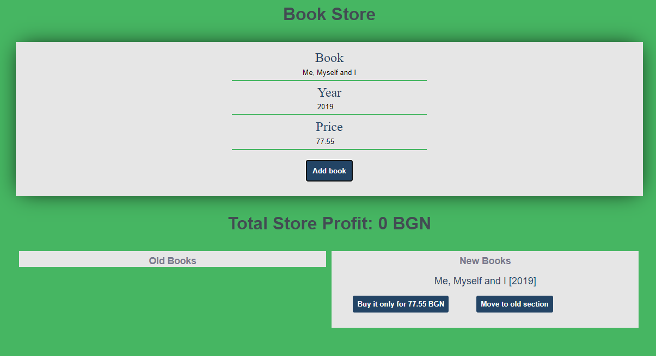

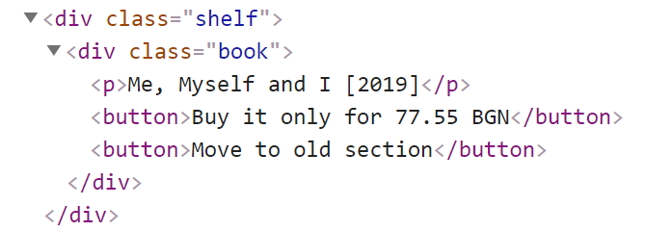

* + **button** with text content "**Buy it only for {bookPrice} BGN**" and **functionality** when is being clicked the **current book should be removed** from the current section and the **total store profit** is **increased** with the given **book price**.

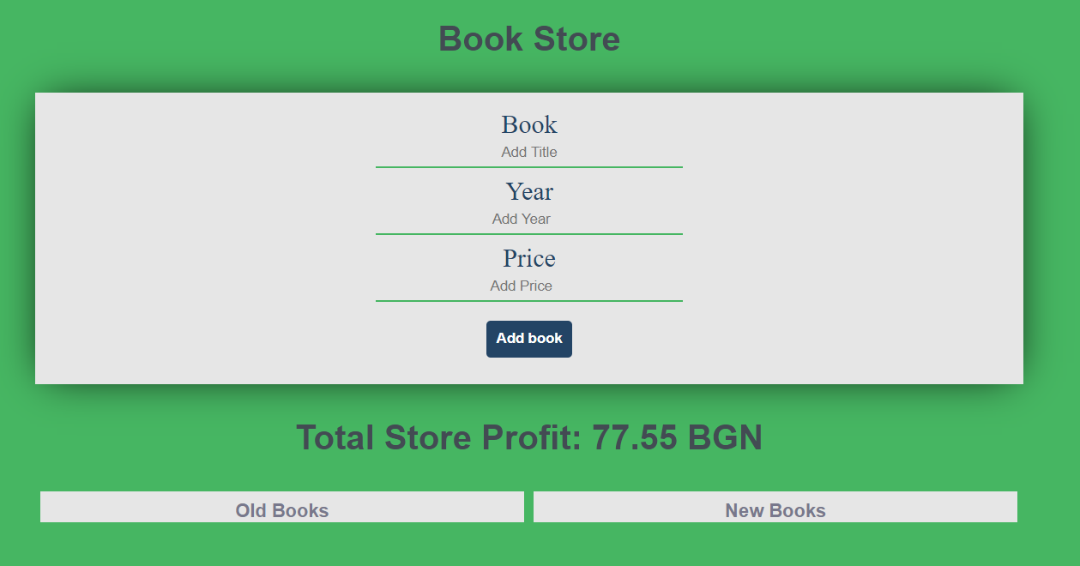

* + (**only applies to new books**) **button** with text content "**Move to old section**" which have the **functionality** when is being clicked the current book should be **moved** from the new books section to the **old books section**.

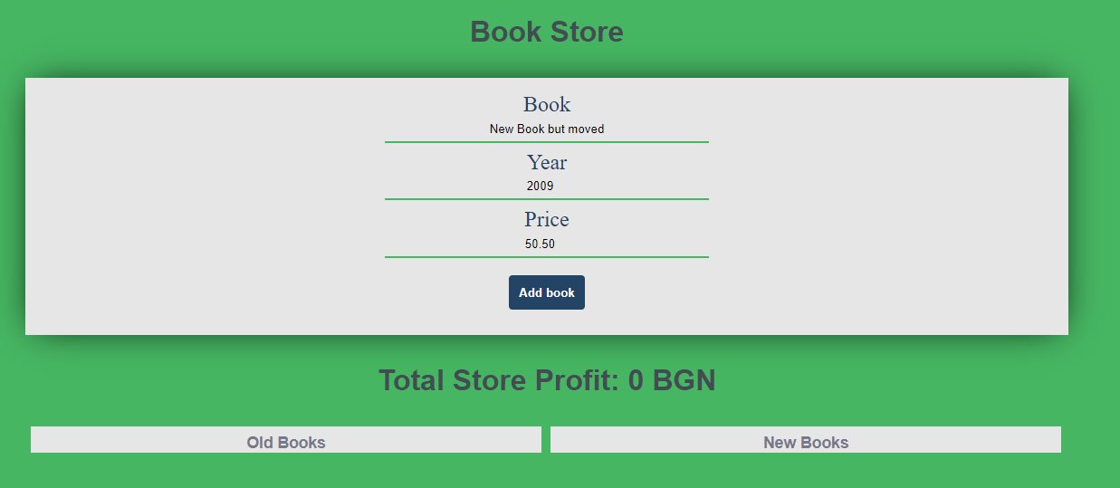

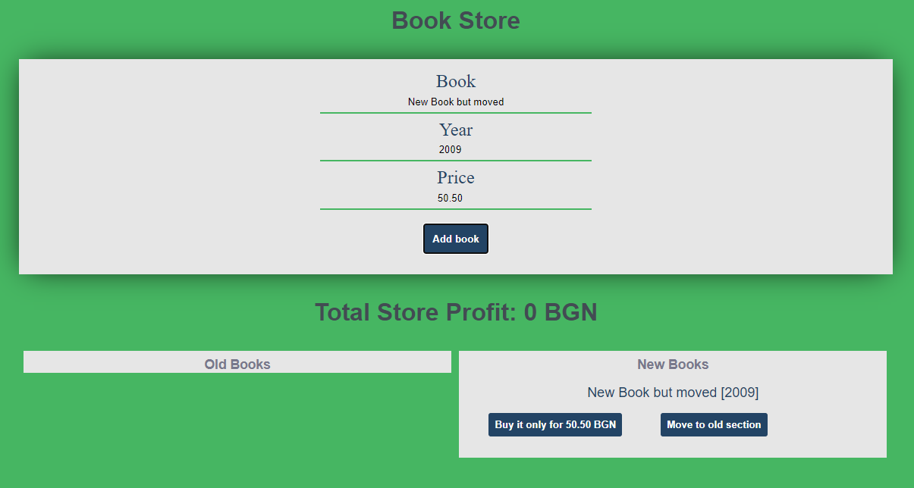

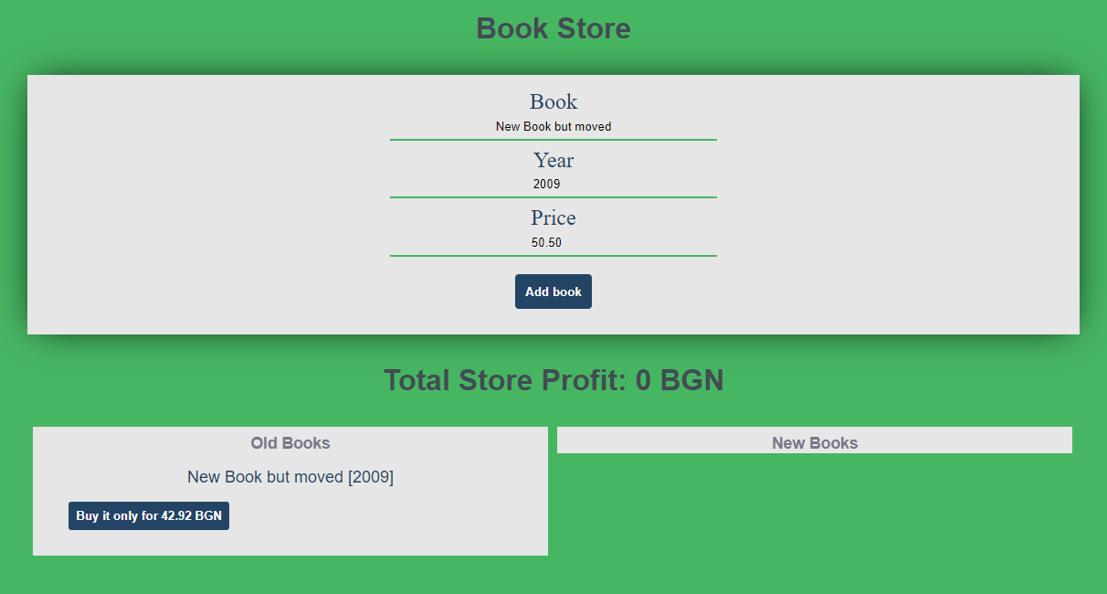

### Constraints

Every price should be **rounded** to the **second** **decimal** **part (toFixed(2))**

Every **old book price** has **15% discount** from the **initial value** (When being **created** into the **old** **books** **sections** or being **moved** from the new books section to **the old books section**)

Each **book's year** **equal** or **higher** than **2000** is consider for a **new book.**

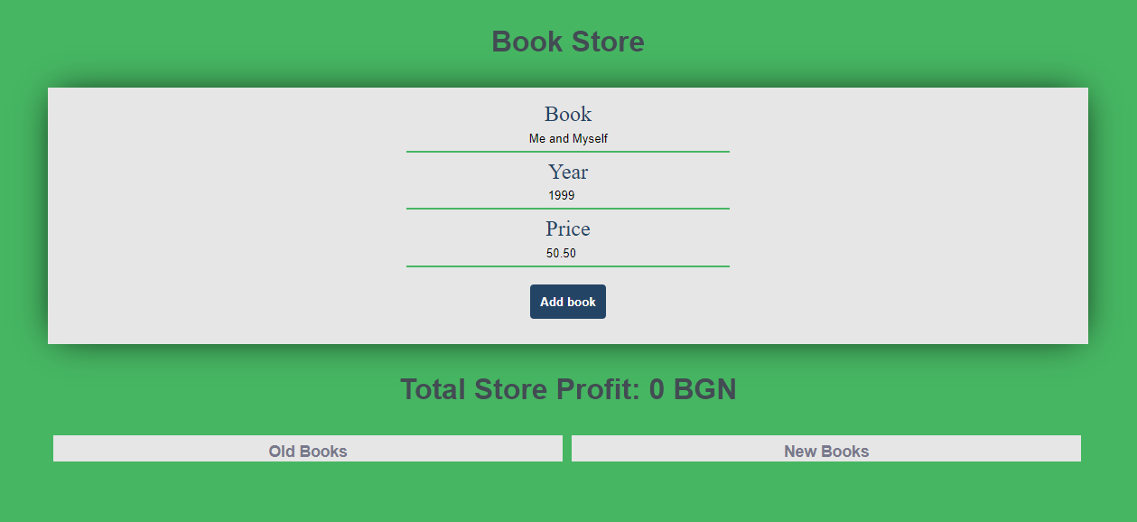

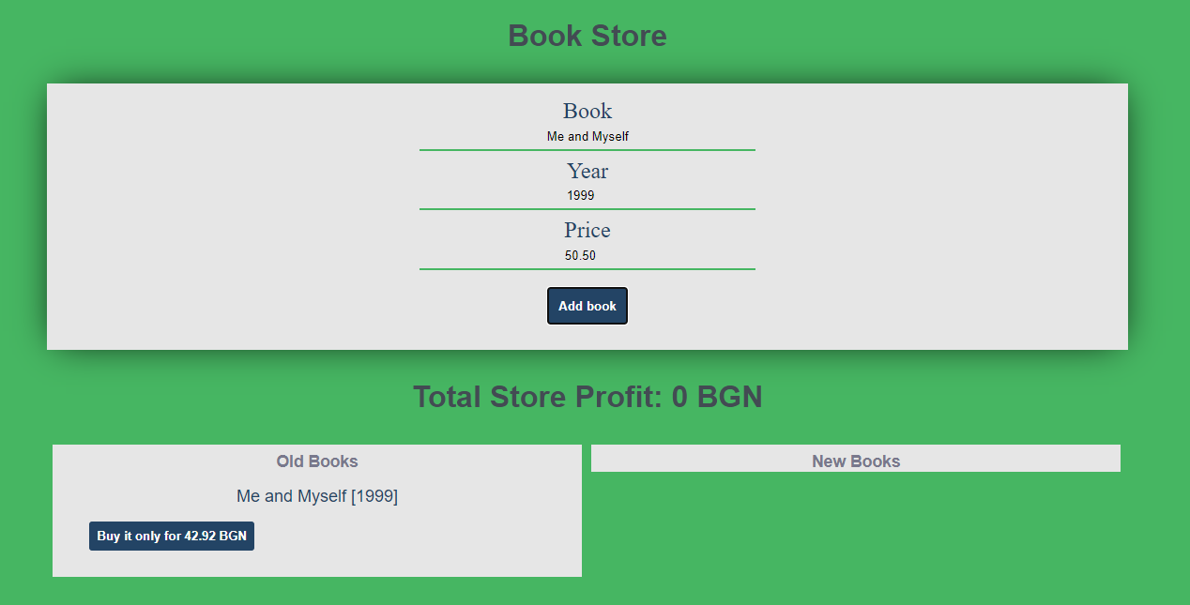

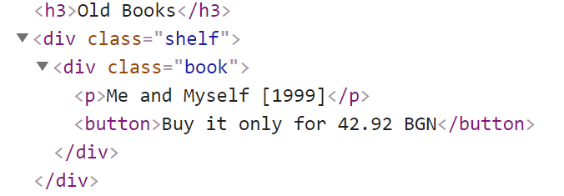

### Submission

Submit only yours **solve()** function.